CS 540 Project
Describe the purpose and audiences for your data-driven narrative: The purpose of this report is to aid a newly formed non-profit company that received a federal government grant to look into reports of rising costs and lower wages negatively impacting the average American and to set up free financial aid clinics in effected areas. The scope of this report is to examine and create figures based on US government data for income reported on tax returns (IRS, 2026), household debt to income ratios (FRB, 2026), and childcare costs by US county (DOL, n.d.) for the period of 2019 to 2022. Figures 1 through 4 provide information referenced in the Jupyter notebook file.
Descriptions of the two groups of stakeholders: The two primary stakeholders are Officers and Board members and new employees. The Officers and Board members are responsible for briefing the federal and state governments on the situation and coordinating funding and resources. This requires information on a national and regional scale. The employees of the newly formed company need to obtain a general understanding of these trends and will be responsible for proposing the financial clinic locations and assisting their clients once a location is opened. The companies’ resources are limited so it is necessary to identify high-risk areas to serve.
Develop a compelling data-driven narrative using storytelling principles:
Officer and Board members: There has been growing concern recently regarding the average American’s ability to pay for necessary expenses while costs increase, and the data provided outlines three critical aspects of this situation: income, household debt, and childcare costs. One common source of confusion regarding rising costs is inflation, or the decline in the purchasing power of the dollar over time. For example, in 2019 an item can be purchased for $1.00 while in 2022 that same item would cost $1.15; the intrinsic value of the item has not increased rather the purchasing power of the dollar has decreased. Thus, inflation does play a role in rising cost; however, this report will focus on real changes in income and costs that have been adjusted to remove the impact of inflation, please see Figure 5. In examining the income data obtained from the IRS the national average annual income has decreased by approximately 10.43% between 2021 and 2022, please see Figure 6. Additionally, wages and salaries have decreased slightly by approximately 1.05%, please see Figure 6. This decline in income appears to not have an impact on the average household to income ratio provided in the Federal Reserve Board data; this ratio has remained nearly stable during the period of 2019 to 2022, please see Figure 7. In 2022, there does not appear to be any correlation between the income-levels and debt, please see Figure 8. The points are scattered and do not show a linear pattern, indicating that other factors outside of income are driving the average American’s level of debt. While income has declined, the average annual cost for one child’s care has increased (6.45% for infants, 3.94% for toddlers, and 4.18% for preschoolers) from 2021 to 2022, please see Figure 9, based on the US Department of Labor Data. In looking at the Average Income per Person by State and the Average Wage per Person by State, the decrease in 2022 is mostly consistent across all states and the decrease is not therefore the result of a couple of states declining but rather an overall national decline in inflation wages income and wages, please see Figures 10 and 11. In turning toward the regional data Figures 12 and Figure 13 demonstrate that no one region’s average income per person is below the National Poverty Line. The dashboard for each region outlines the average wages per person in each state in 2022, the average annual childcare costs as a percentage of the median family income reported by the Department of Labor for 2022, and the average household debt to income ratio for 2022, please see Figures 14 through 17. These figures indicate that there is variation by region in the national trends seen. Across all regions, Center-Based childcare is consistently more expensive than family childcare, please see Figures 14.2, 15.2, 16.2, and 17.2. Additionally, both the Northeast and West regions have higher percentages than the Midwest and South Regions. The regional data also shows that the Northeast and Midwest regions have divisional household debt ratios that are lower than the national average while the South and West regions have higher debt ratios, please see Figures 14.3, 15.3, 16.3, and 17.3. In conclusion, due to the decline in income between 2019 and 2022, the primary focus should be on the allocation of resources and subsidies to reduce expenses like childcare, specifically in the Northeast and West Regions in order to reduce the negative impact of this decline in income.
Employees: As seen recently on the news, the average American’s financial condition is declining as income decreases and expenses increase. This was verified for 2022 in the income data provided by the IRS; when summarized it shows the national average income per person had declined between 2021 and 2022, please see Figure 6. At the same time childcare expenses, based on the data provided by the Department of Labor have increased, please see Figure 9. Part of this company’s mission and purpose is the creation of free financial clinics to offer information on financial government assistance to high-risk areas. As seen in Figures 18, 19, and 20 there is variation in the color gradient between different areas of the country and between different states, this indicates the importance of looking deeper into the specifics of each state. The following visualizations provide a county breakdown of income, household debt ratios, and childcare costs to assist in looking for suitable locations for financial clinics. Figure 21 shows the US map broken down by county, or choropleth, and is colored based on whether it is far above the Federal poverty line (green), approaching the Federal poverty line (blue), or at or under the Federal poverty line. The graph can be filtered to show counties that present high-risk financial distress, please see Figure 22. Figure 23, shows the US map broken down by county with coloring based on the county’s average household debt ratio in 2022. Green indicates a lower than national average ratio, blue indicates a ratio that is higher than the national average but less than 2.5, and purple indicates a ratio that is equal to or higher than 2.6. As seen in Figure 24, the higher risk counties in terms of debt are spread throughout the country and do not appear to follow a pattern or be isolated to a region or area. Finally, Figure 25 shows the US map broken down by the average annual childcare cost for 2022. Counties colored green have an average cost below the national average, blue counties have a cost within the national average range of $7,400 to $8,400, and red indicates a cost above the national average. When filtering the data, please see Figure 26, some state patterns can be seen, for instance the majority of counties in California, Arizona, and Colorado having above average costs. In conclusion, the figures described above demonstrate that the initial analysis for financial clinics should be based on the under Federal poverty level and approaching poverty level counties in Figure 22 to begin offering assistance with low-income programs; and California, Arizona, and Colorado should be the primary focus for locations offering childcare resources and information regarding government subsidies. Since the high household debt ratios counties are vast and span the country, the analysis should consider whether it is financially feasible owing to the limited resources to be able to provide services regarding debt management.
Evaluate the effectiveness of your chosen visualizations in communicating your data insights: The chosen visualizations are an effective means of conveying the information to the intended audiences in the following ways. First, the figures and the written analysis begin at a high level and progressively reveal additional and more detailed information once the audience understands what is happening at a broader level. Second, the visualizations incorporate color-blind friendly palettes and include detailed visualization titles, axis labels, legends, and data labels so the intended audiences don’t need to use the axis scales to try and visually estimate the data point values. Third, the regional dashboards created for the Officer and Board member audience effectively summarize the information for each region in an easy to use and understand format. Fourth, the county choropleth figures created for the employees are colored coded for ease of use and understanding so that one color represents values below a threshold, the second color represents values within a national average range, and a third color represents values exceeding the national average.
Customize your integrated visualizations to help each audience better understand the insights and a justification of how your customization choices improve visualization clarity and highlight key insights: With regards to the Officer and Board member audience, the regional dashboards allow for all data types (income, household debt to income ratio, and childcare costs) to be summarized in one figure, please note that the dashboard figures are separated into individual graphs for the purposes of this report but in a combined form in the Jupyter file. This allows them to be able to understand with ease the unique characteristics of each region, make comparisons with other regions, and highlight key differences between regions. With regards to the employee audience, the interactive choropleths showing county-level information for the income, household debt to income ratio, and childcare costs data allow for them to easily filter the counties based on the relevant criteria, and is less visually overwhelming than trying to discern the important counties when looking at the complete map. These figures and their filtering allow for the employees to easily make comparisons between the national averages and the county data to highlight higher financial risk areas that might make ideal locations for the financial clinics which the company will begin to open.

References
ASPE. (n.d.). Prior HHS Poverty Guidelines and Federal Register References. Retrieved from Office of the Assistant Secretary for Planning and Evaluation: https://aspe.hhs.gov/topics/poverty-economic-mobility/poverty-guidelines/prior-hhs-poverty-guidelines-federal-register-references
BLS. (n.d.). CPI Inflation Calculator. Retrieved from U.S Bureau of Labor Statistics: https://www.bls.gov/data/inflation_calculator.htm
DOL. (n.d.). National Database of Childcare Prices [Data set]. Retrieved from U.S. Department of Labor, Women's Bureau: https://www.dol.gov/agencies/wb/topics/featured-childcare
FCC. (n.d.). Federal Information Processing System (FIPS) Codes for States and Counties. Retrieved from Federal Communications Commission: https://transition.fcc.gov/oet/info/maps/census/fips/fips.txt
FRB. (2026, June 18). County-Level Debt-to-Income Ratio, 2019-2022 [Data set]. Retrieved from Board of Governors of the Federal Reserve System: https://www.federalreserve.gov/releases/z1/dataviz/household_debt/county/map/#state:all;year:2025
GitHub User Content GeoJson Counties FIPS. (n.d.). Retrieved from GitHub: https://raw.githubusercontent.com/plotly/datasets/master/geojson-counties-fips.json
IRS. (2026, August 24). SOI Tax Stats - County data, 2019 to 2022 [Data set]. Retrieved from Internal Revenue Service: https://www.irs.gov/statistics/soi-tax-stats-county-data
QuickFacts Loving County, Texas. (n.d.). Retrieved from United States Census Bureau: https://www.census.gov/quickfacts/fact/table/lovingcountytexas/PST045225
USCB. (2021, October 8). Geographic Levels. Retrieved from United States Census Bureau: https://www.census.gov/programs-surveys/economic-census/guidance-geographies/levels.html#par_textimage_38
USCB. (n.d.). QuickFacts. Retrieved from United States Census Bureau: https://www.census.gov/quickfacts/fact/table/miamidadecountyflorida/POP060210

Figures
Figure 1: IRS Data Column Title Meaning
IRS Data Column | Data Column Meaning
STATEFIPS | State FIPs code
STATE | State abbreviation
COUNTYFIPS | County FIPS code
COUNTYNAME | Name of county
agi_stub/AGI_STUB | Size of taxpayer Adjusted Gross Income (AGI)  0 = No AGI Total  1 = under $1  2 = $1 under $10,000  3 = $10,000 under $25,000  4 = $25,000 under $50,000  5 = $50,000 under $75,000  6 = $75,000 under $100,000  7 = $100,000 under $200,000  8 = $200,000 or more
N1 | Number of tax returns
Mars1/MARS1 | Number of single tax returns
MARS2 | Number of married filing jointly (MFJ) tax returns
MARS4 | Number of head of household (HOH) tax returns
N2 | Number of Individuals
A02650 | Total tax return income amount (reported in thousands)
A00200 | Total tax return salaries and wages amount (reported in thousands)
Figure Source: (IRS, 2026)
Figure 2: US Bureau of Labor Statistics Inflation Adjustments
Original Period | Period to Adjust to | Original Value | Inflation-Adjusted Value | Percentage
December 2019 | December 2022 | $1.00 | $1.15 | 15%
December 2020 | December 2022 | $1.00 | $1.14 | 14%
December 2021 | December 2022 | $1.00 | $1.06 | 106%
Figure Source: (BLS, n.d.)

Figure 3: US Department of Labor Childcare Costs Data Column Title Meaning
Childcare Costs Data Column | Data Column Meaning
STATE_NAME | State name
STATE_ABBREVIATION | State abbreviation
COUNTY_NAME | Name of county
COUNTY_FIPS_CODE | County FIPS Code
STUDYYEAR | Year
MFI_2022 | Median family income (inflation adjusted to 2022 dollars)
MCInfant | Weekly median price of full-time child care center for infants (0 to 23 months)
MCToddler | Weekly median price of full-time child center care for toddlers (24 to 35 months)
MCPreschool | Weekly median price of full-time child center care for preschoolers (36 to 54 months)
MFCCInfant | Weekly median price of full-time family childcare for infants (0 to 23 months)
MFCCToddler | Weekly median price of full-time family childcare for toddlers (24 to 35 months)
MFCCPreschool | Weekly median price of full-time family childcare for preschoolers (36 to 54 months)
Figure Source: (DOL, n.d.)

Figure 4: US Census Bureau State Regions and Divisions
US Region | US Division | States
Northeast Region | New England Division | Connecticut, Maine, Massachusetts, New Hampshire, Rhode Island, and Vermont
Northeast Region | Middle Atlantic Division | New Jersey, New York, and Pennsylvania
Midwest Region | East North Central Division | Illinois, Indiana, Michigan, Ohio, and Wisconsin
Midwest Region | West North Central Division | Iowa, Kansas, Minnesota, Nebraska, North Dakota, and South Dakota
South Region | South Atlantic Division | Delaware, District of Columbia, Florida, Georgia, Maryland, North Carolina, South Carolina, Virginia, and West Virginia
South Region | East South Central Division | Alabama, Kentucky, Mississippi, and Tennessee
South Region | West South Central Division | Arkansas, Louisiana, Oklahoma, and Texas
West Region | Mountain Division | Arizona, Colorado, Idaho, Montana, Nevada, New Mexico, Utah, and Wyoming
West Region | Pacific Division | Alaska, California, Hawaii, Oregon, and Washington
Figure Source: (USCB, 2021)

Figure 5: Inflation Impact on US Dollar ($) between 2019 and 2022
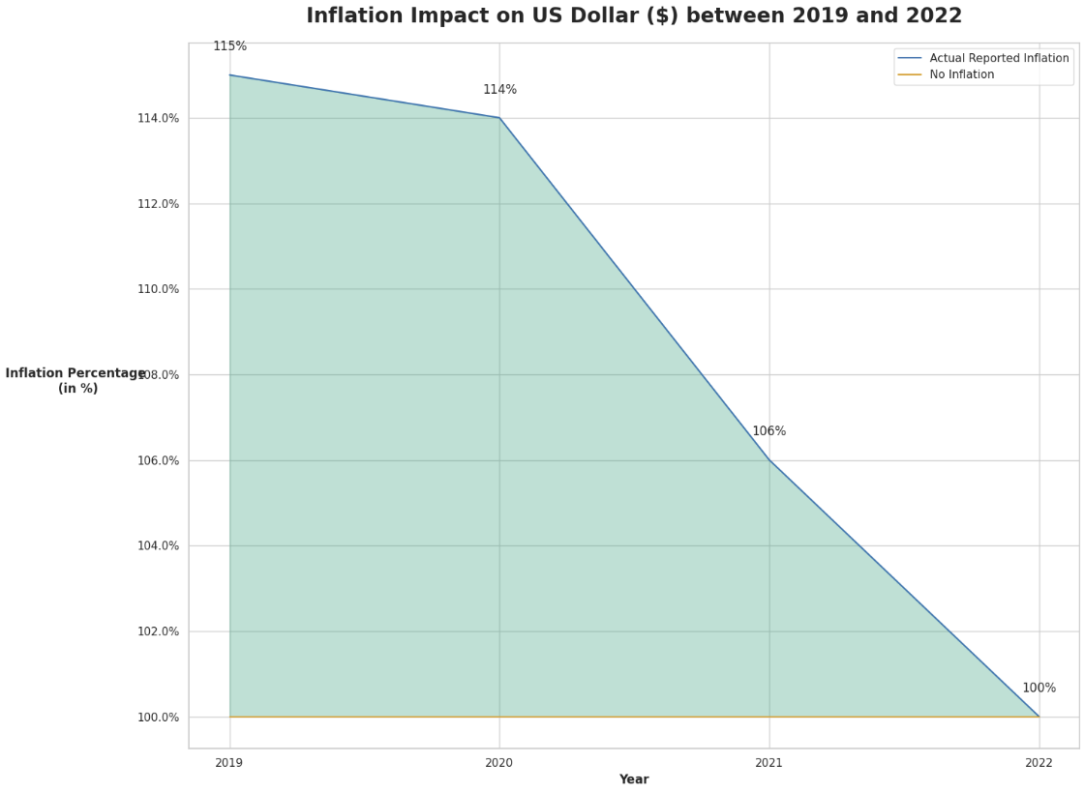
Figure Data Source: (BLS, n.d.)
Figure 6: National Average Adjusted Income & Wages per Person for 2019-2022
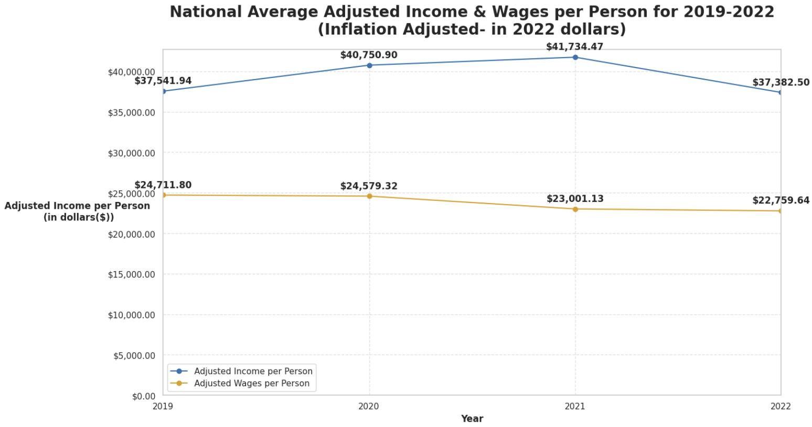
Figure Data Source: (IRS, 2026)
Figure 7: National Average Household Debt Ratio for 2019-2022
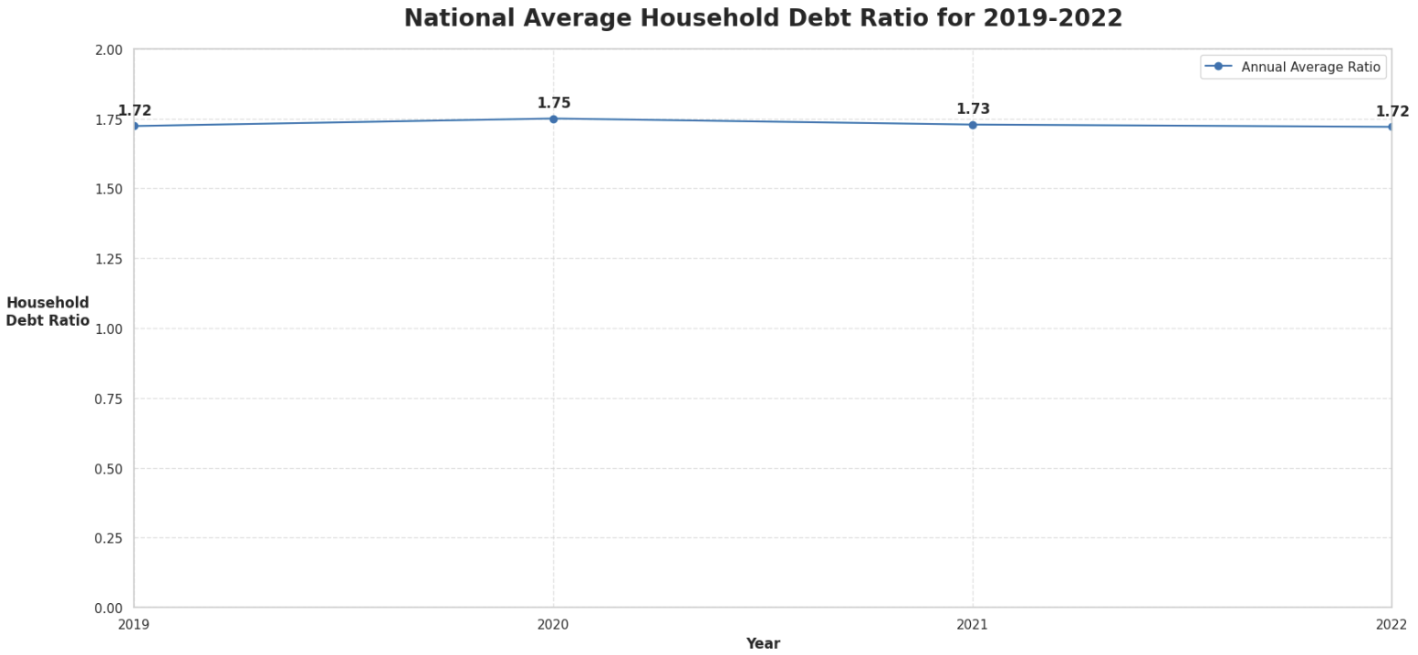
Figure Data Source: (FRB, 2026)

Figure 8: Average Adjusted Income per Person vs. Annual Average Household Debt Ratio in 2022
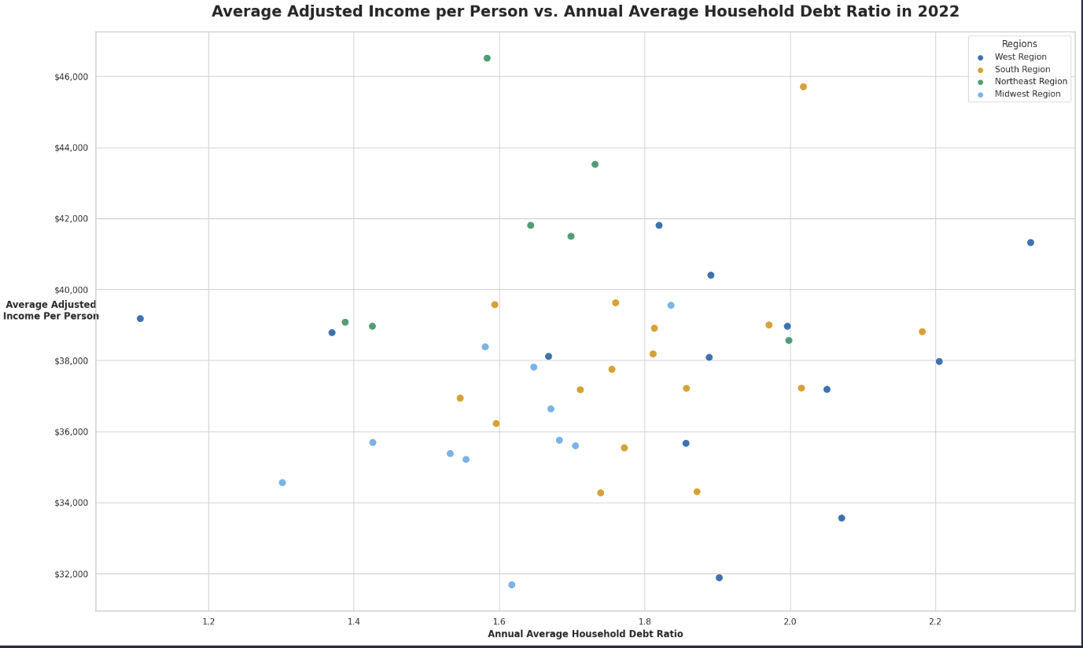
Figure Data Source: (IRS, 2026) and (FRB, 2026)
Figure 9: National Annual Average Childcare Costs per Child for 2019-2022
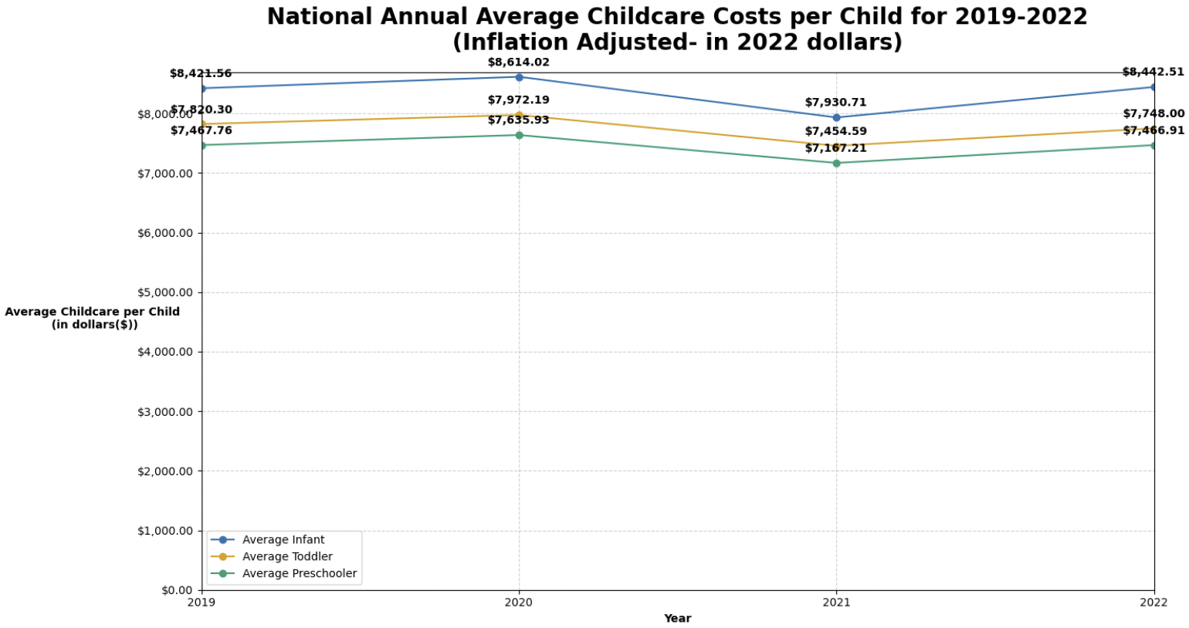
Figure Data Source: (DOL, n.d.)

Figure 10: Average Income per Person by State (2019 to 2022) (please see Jupyter file for interactive features)
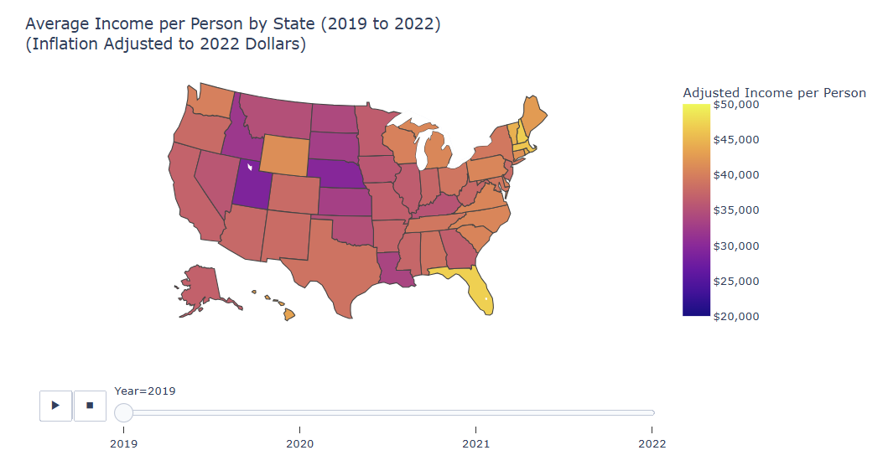
Figure Data Source: (IRS, 2026)
Figure 11: Average Wages per Person by State (2019 to 2022) (please see Jupyter file for interactive features)
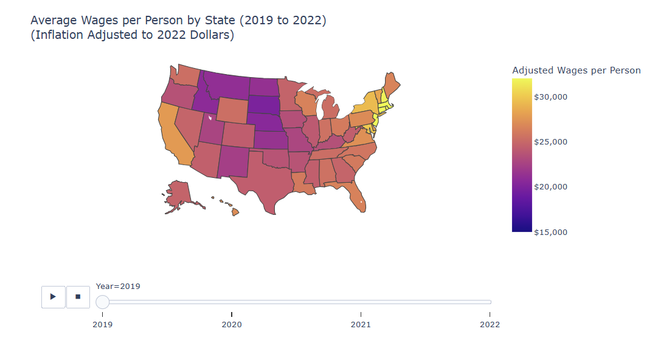
Figure Data Source: (IRS, 2026)
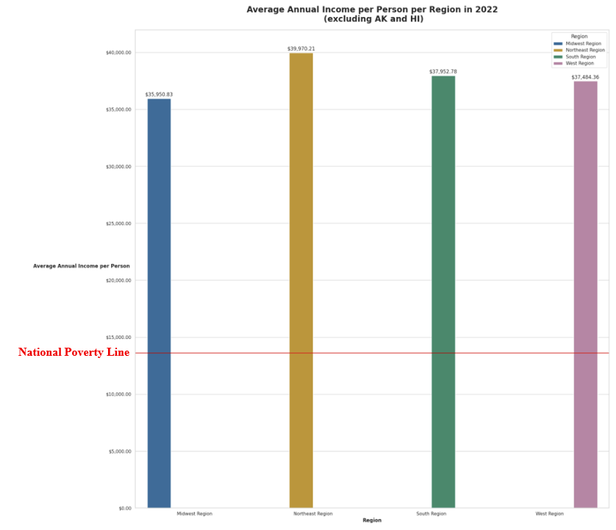
Figure 12: Average Annual Income per Person per Region in 2022 (excluding AK and HI)
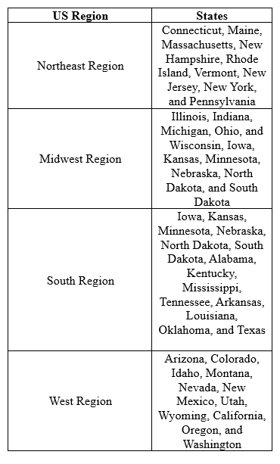

Figure Data Source: (IRS, 2026) and (ASPE, n.d.)
Figure 13: Average Annual Income per Person for Alaska & Hawaii in 2022
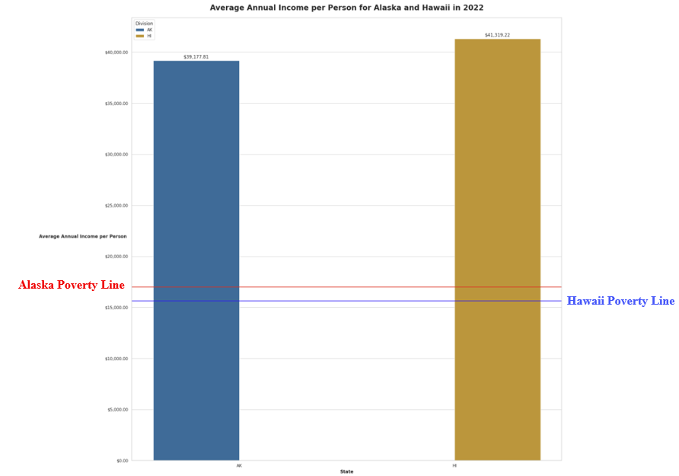
Figure Data Source: (IRS, 2026) and (ASPE, n.d.)
Figure 14: Northeast Region Dashboard (please see Jupyter file for interactive features)
Figure 14.1: Northeast Region Dashboard Figure (2022 Regional Choropleth)
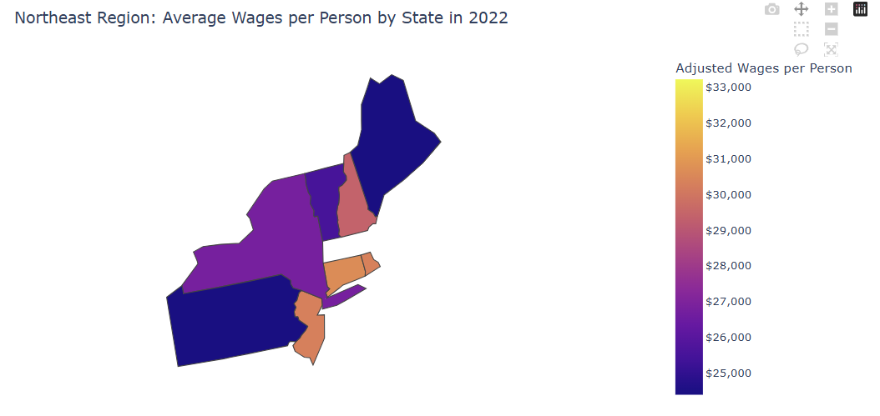
Figure Data Source: (IRS, 2026)

Figure 14: Northeast Region Dashboard (please see Jupyter file for interactive features)
Figure 14.2: Northeast Region Dashboard Figure (2022 Childcare Costs Comparison)
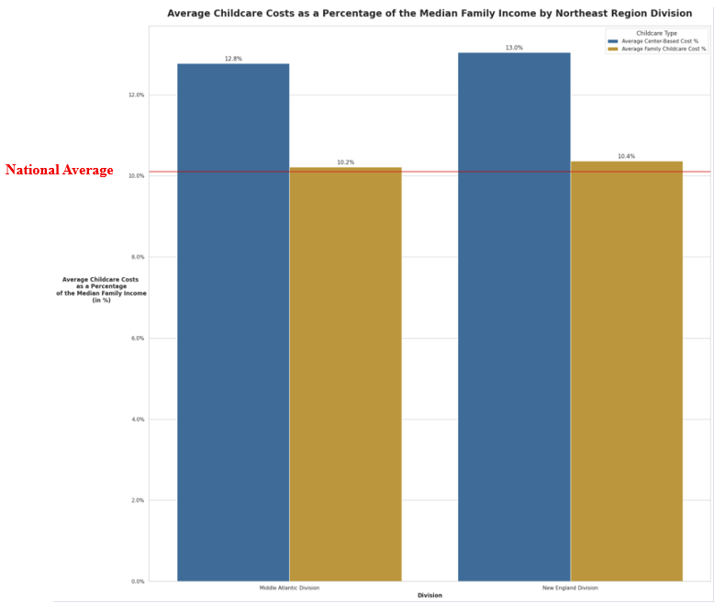
Figure Data Source: (DOL, n.d.)
Figure 14: Northeast Region Dashboard (please see Jupyter file for interactive features)
Figure 14.3: Northeast Region Dashboard Figure (2022 Household Debt Comparison)
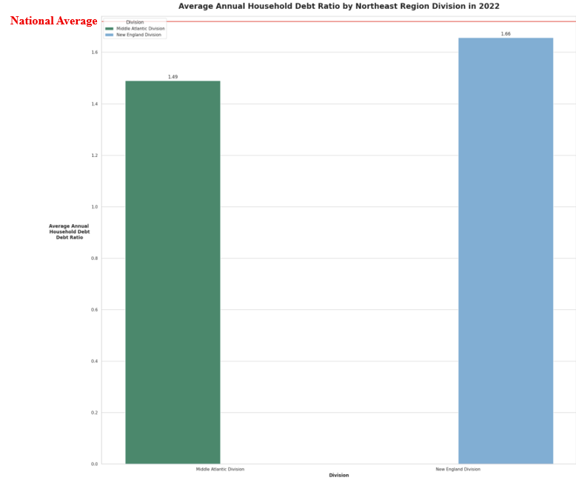
Figure Data Source: (FRB, 2026)
Figure 15: Midwest Region Dashboard (please see Jupyter file for interactive features)
Figure 15.1: Midwest Region Dashboard Figure (2022 Regional Choropleth)
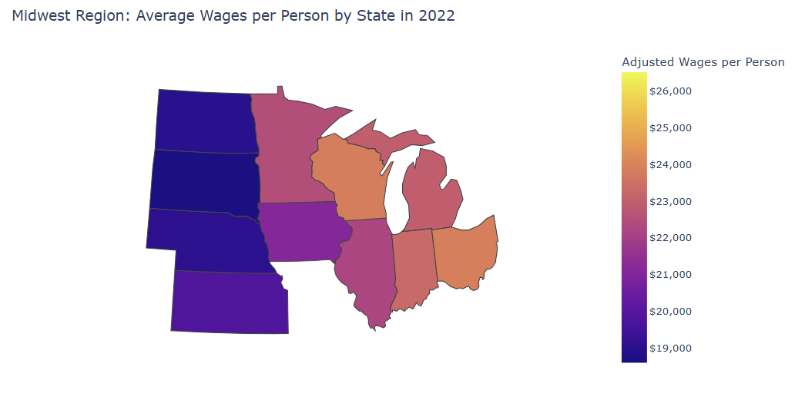
Figure Data Source: (IRS, 2026)

Figure 15: Midwest Region Dashboard (please see Jupyter file for interactive features)
Figure 15.2: Midwest Region Dashboard Figure (2022 Childcare Costs Comparison)
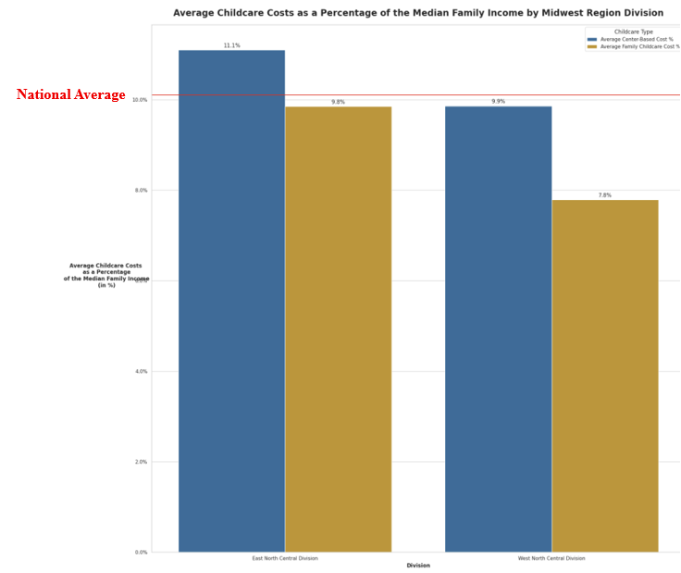
Figure Data Source: (DOL, n.d.)

Figure 15: Midwest Region Dashboard (please see Jupyter file for interactive features)
Figure 15.3: Midwest Region Dashboard Figure (2022 Household Debt Comparison)
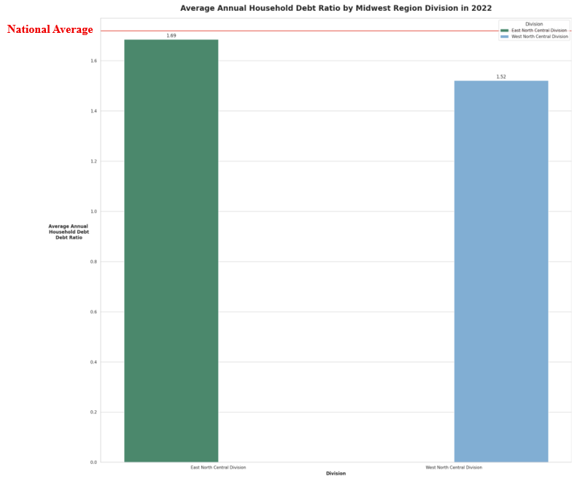
Figure Data Source: (FRB, 2026)
Figure 16: South Region Dashboard (please see Jupyter file for interactive features)
Figure 16.1: South Region Dashboard Figure (2022 Regional Choropleth)
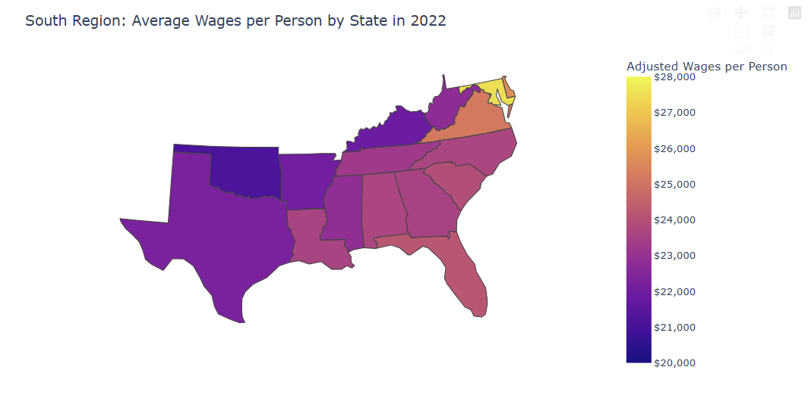

Figure Data Source: (IRS, 2026)

Figure 16: South Region Dashboard (please see Jupyter file for interactive features)
Figure 16.2: South Region Dashboard Figure (2022 Childcare Costs Comparison)
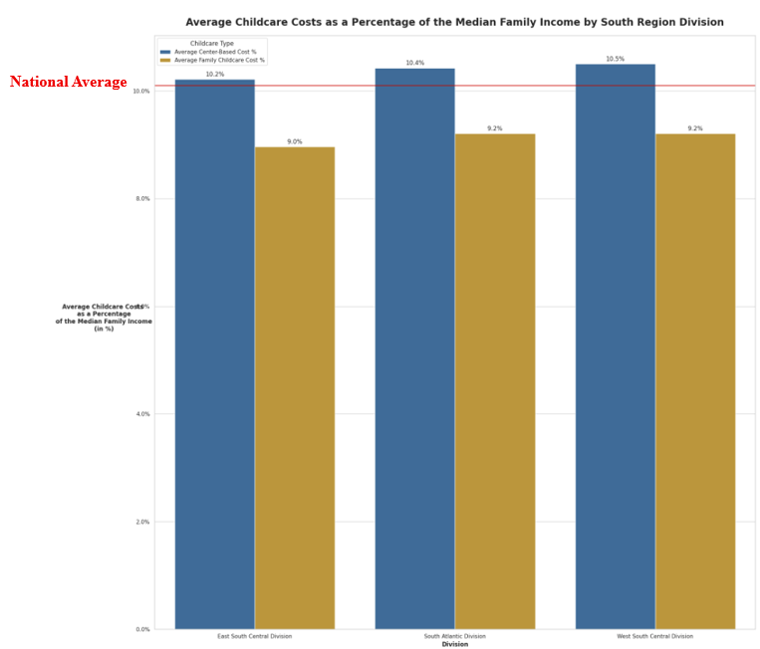
Figure Data Source: (DOL, n.d.)
Figure 16: South Region Dashboard (please see Jupyter file for interactive features)
Figure 16.3: South Region Dashboard Figure (2022 Household Debt Comparison)
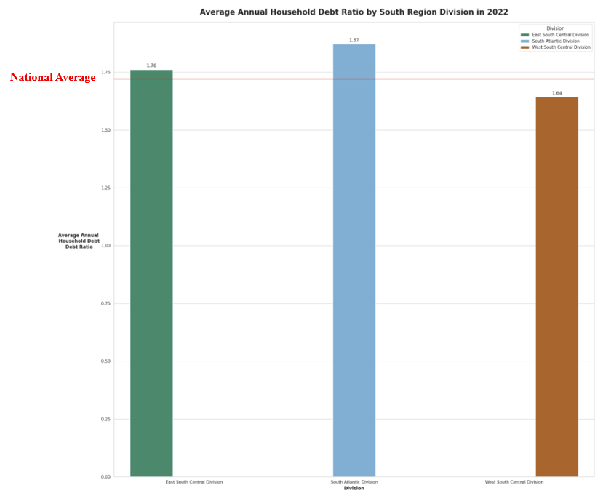
Figure Data Source: (FRB, 2026)
Figure 17: West Region Dashboard (please see Jupyter file for interactive features)
Figure 17.1: West Region Dashboard Figure (2022 Regional Choropleth)
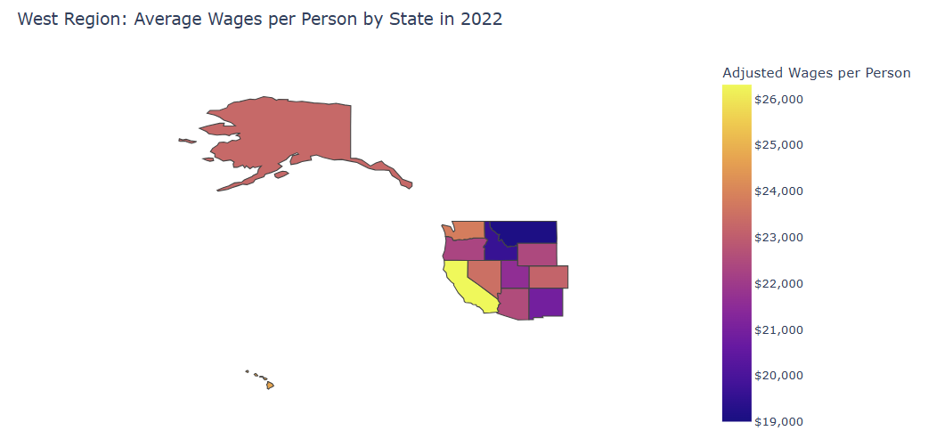
Figure Data Source: (IRS, 2026)

Figure 17: West Region Dashboard (please see Jupyter file for interactive features)
Figure 17.2: West Region Dashboard Figure (2022 Childcare Costs Comparison)
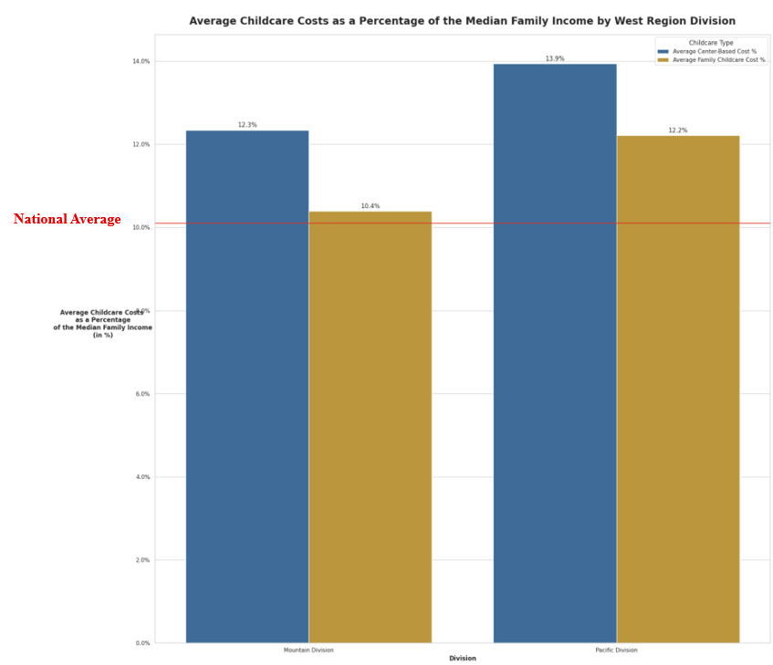
Figure Data Source: (DOL, n.d.)
Figure 17: West Region Dashboard (please see Jupyter file for interactive features)
Figure 17.3: West Region Dashboard Figure (2022 Household Debt Comparison)
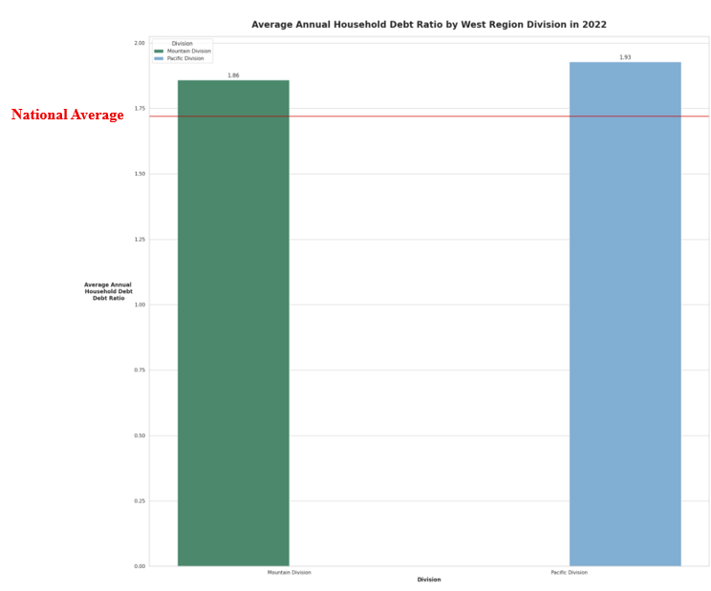
Figure Data Source: (FRB, 2026)

Figure 18: Average Annual Income per Person by State (2022) (please see Jupyter file for interactive features)
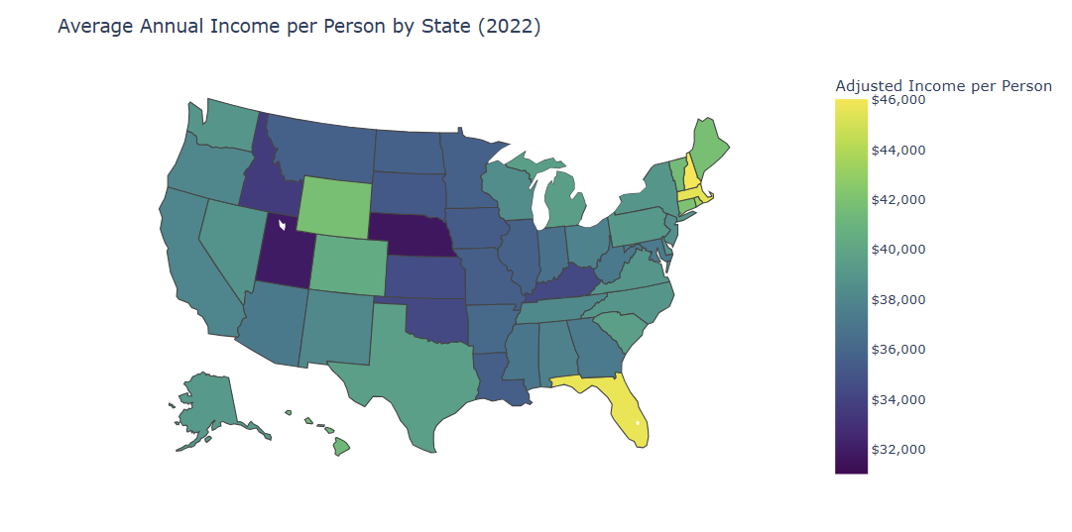
Figure Data Source: (IRS, 2026)

Figure 19: Average Annual Wages per Person by State (2022) (please see Jupyter file for interactive features)
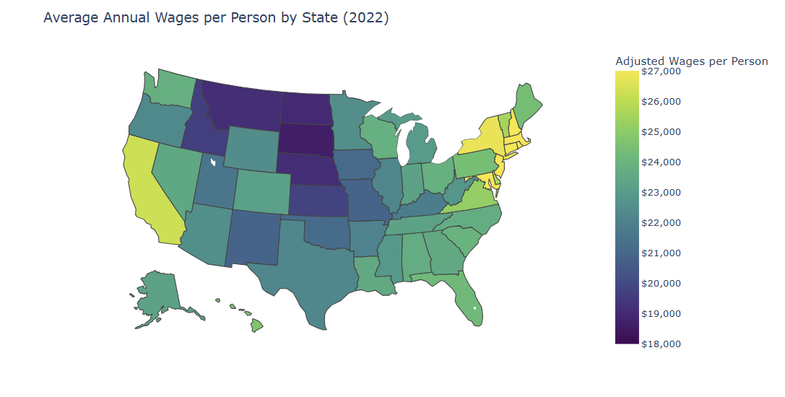
Figure Data Source: (IRS, 2026)

Figure 20: Average Household Debt Ratio (please see Jupyter file for interactive features)
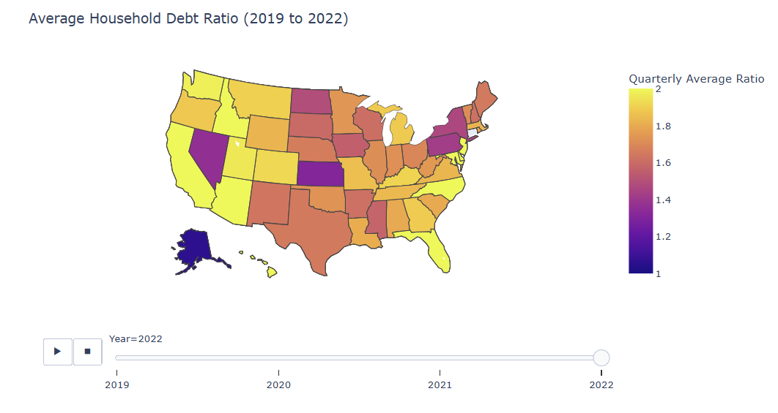
Figure Data Source: (FRB, 2026)

Figure 21: Map of 2022 Average Annual County Income per Person in Comparison with Federal Poverty Level
(please see Jupyter file for interactive features)
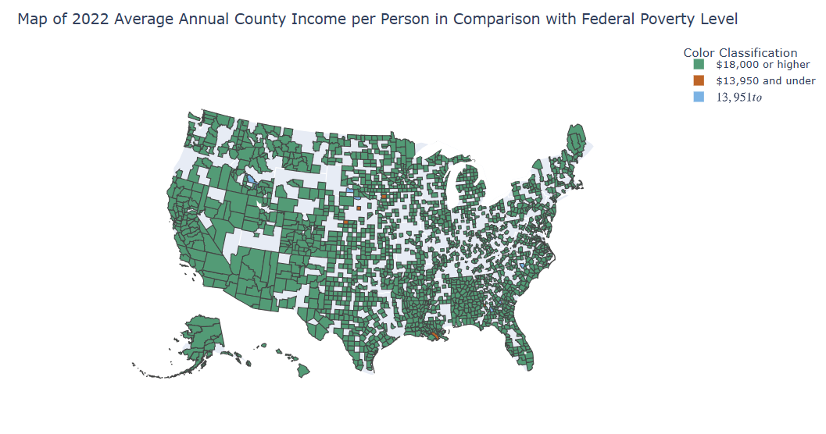
Figure Data Source: (IRS, 2026)

Figure 22: Map of 2022 Average Annual County Income per Person in Comparison with Federal Poverty Level- Filtered
(please see Jupyter file for interactive features)
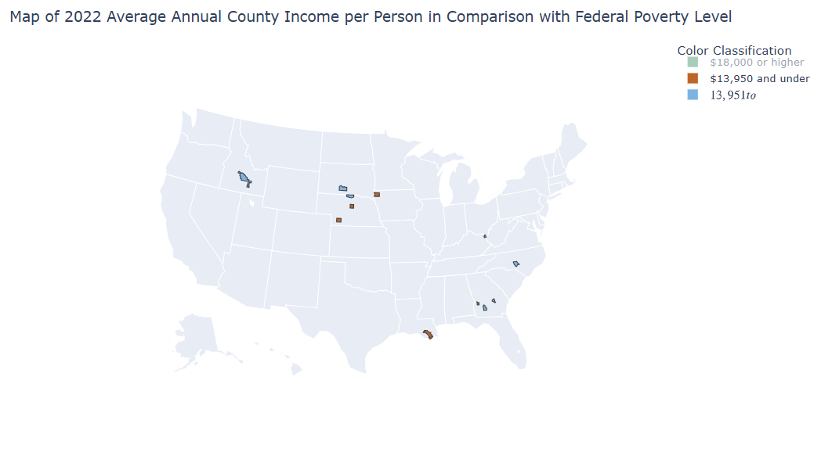
Figure Data Source: (IRS, 2026)

Figure 23: Map of 2022 Average Annual County Household Debt to Income Ratio in Comparison with National Average
(please see Jupyter file for interactive features)
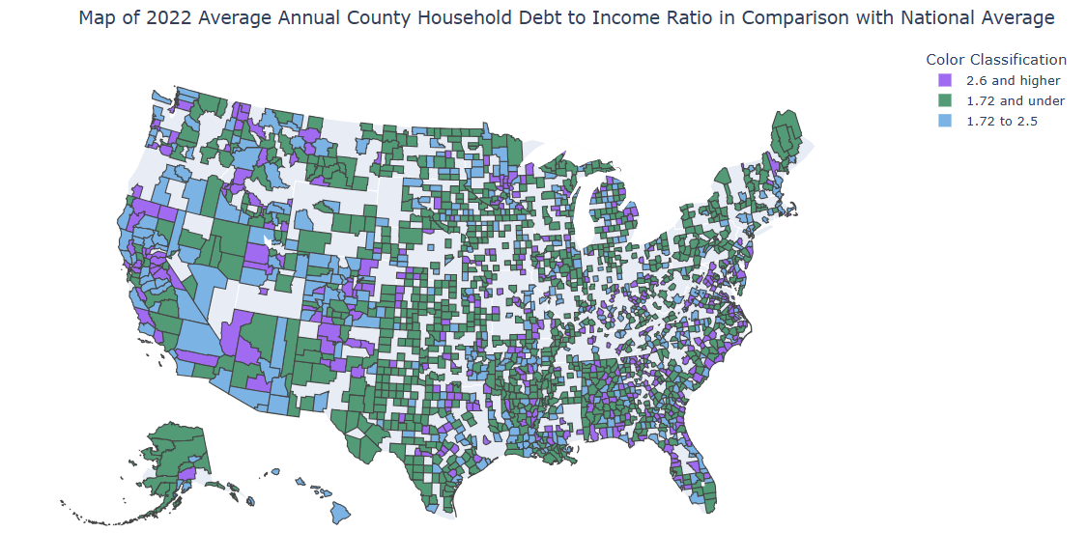
Figure Data Source: (FRB, 2026)

Figure 24: Map of 2022 Average Annual County Household Debt to Income Ratio in Comparison with National Average- Filtered
(please see Jupyter file for interactive features)
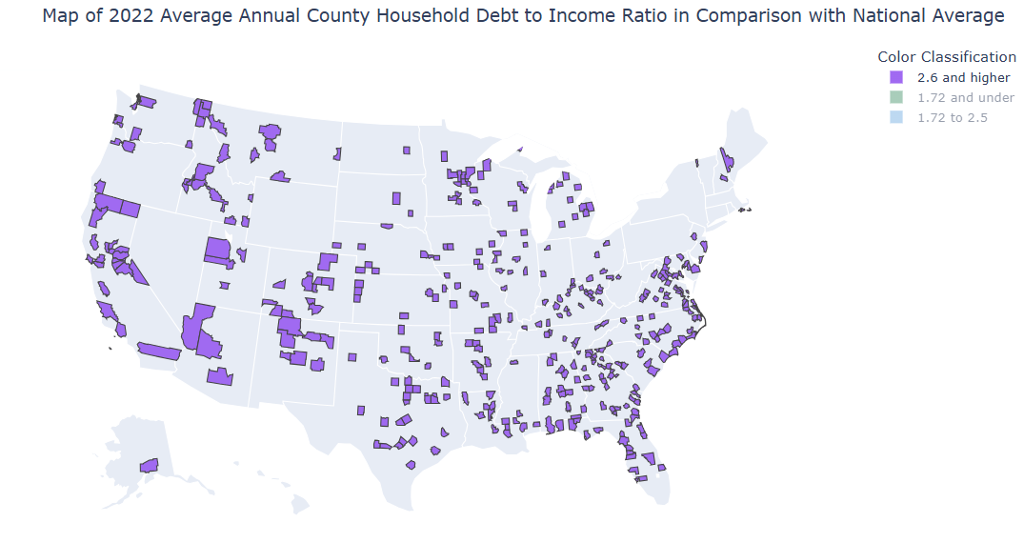
Figure Data Source: (FRB, 2026)

Figure 25: Map of 2022 Average Annual County Childcare Costs in Comparison with National Average
(please see Jupyter file for interactive features)
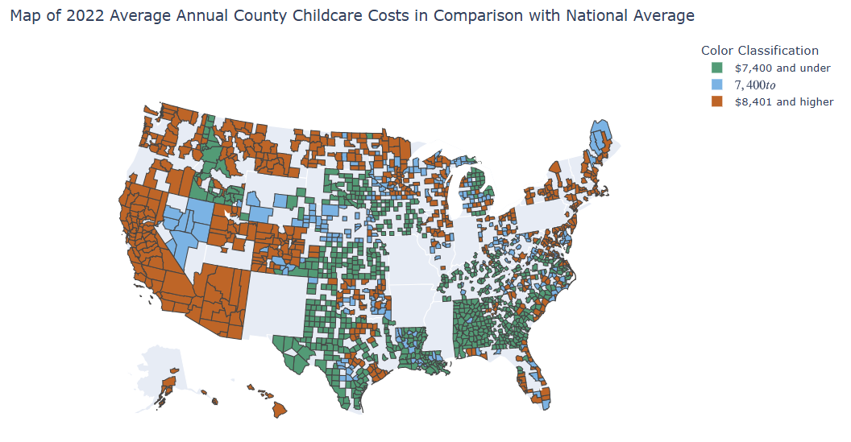

Figure Data Source: (DOL, n.d.)

Figure 26: Map of 2022 Average Annual County Childcare Costs in Comparison with National Average- Filtered
(please see Jupyter file for interactive features)
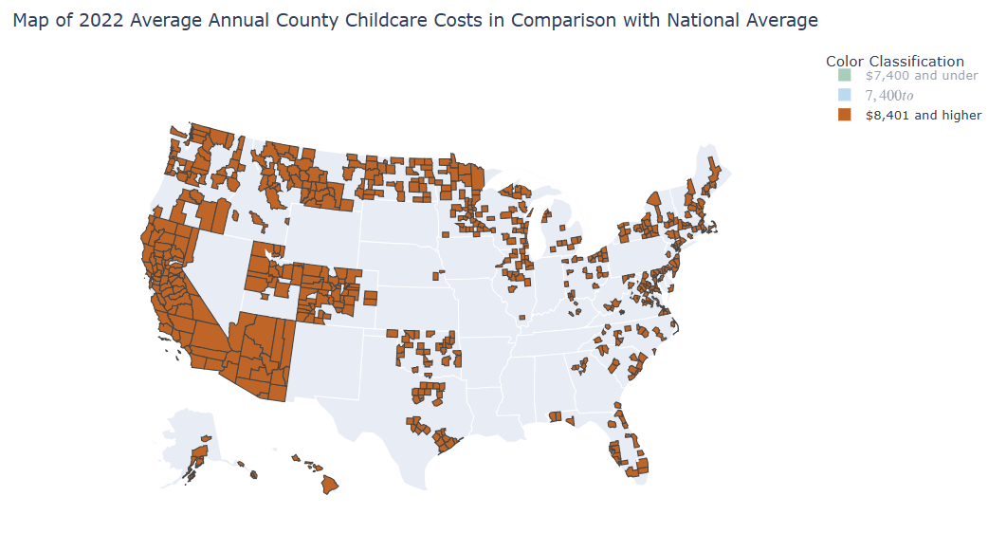

Figure Data Source: (DOL, n.d.)

The original IRS data contained data for three counties with income data but no individuals; these data points were excluded since they would result in a division by zero error (the three row instances removed were for two counties in Texas in 2019: Kenedy and Sterling County and one county in North Dakota in 2021: Billings County)
The original IRS data contained data for three counties with income data but no individuals, these data points were excluded since they would result in a division by zero error (the three row instances removed were for two counties in Texas in 2019: Kenedy and Sterling County and one county in North Dakota in 2021: Billings County)
The original IRS data contained data for three counties with income data but no individuals, these data points were excluded since they would result in a division by zero error (the three row instances removed were for two counties in Texas in 2019: Kenedy and Sterling County and one county in North Dakota in 2021: Billings County)

